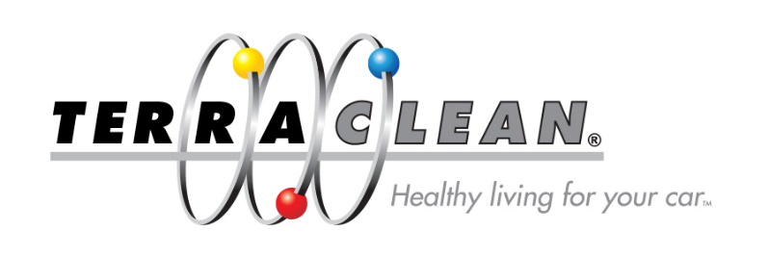
TerraClean Awards 2016
List of Nominees (Winners Highlighted)
Best Newcomer
Paul & Eddie – Elite MOT Service and Repair Ltd
Nick Buist – L.E Cramer Motor Engineering Ltd
Gareth & Nathan – Gwent MOT Station
Brett Wood – B.E Automotive Ltd

Best Dealer’s Dealer
Clive Jones – Mobile Auto Aircon DPF
Tony Waring – Weldbank Garage Ltd
Gary Wood – The Diesel Doctor Ltd
Mike Lyons – DPF Cleaning Ltd

Best Public Feedback
Vic Clarke – Auto Centre Rushden Ltd
Bernie Alleway – A1 TerraClean
Mike Dyer – Kent Engine Clean
Asher Rose – Miles Ahead Motor Services Ltd

Best Social Media
Mike Lyons - DPF Cleaning Ltd
Gary Wood – The Diesel Doctor Ltd
Bernie Alleway – A1 TerraClean
Kevin Martin – Spannerama

Best Technician
Kevin Martin – Spannerama
James Price – James Price Mobile Mechanics
Mike Lyons – DPF Cleaning Ltd
Paul Guyan – Paul’s Garage Services

Best People’s Service Centre
Neil Turner – Turners Auto Services Ltd
Paul & Eddie – Elite MOT Service & Repair Ltd
Chris Warren – Tuna Garage
Kris & Mike – M.J. Motors

Best Mystery Shop
Neil Hansler – Broadstone Car Sales
Nick Buist – L.E Cramer Motor Engineering Ltd
Stewart Campbell – Southwest Towing Ltd
Adrian Squire – A.P.S Vehicle Solutions

Best Mobile
Andy McClurg – Clurgys Services Ltd
Bernie Alleway – A1 TerraClean
Mike Lyons – DPF Cleaning Ltd
Neil Hansler – Broadstone Car Sales

Best Workshop
Vic Clarke – Auto Centre Rushden Ltd
Tony Waring – Weldbank Garage Ltd
Peter Welch – Scotlands Ash Garage
Rob Collinson – Collinson Motoring Services

Overall Service Centre 2016
Mike Lyons – DPF Cleaning Ltd

